User guide

Note taking

website

Paul Băltărete

1. Introduction

This website is meant to make you more productive by offering you a nice user interface to work with. With this website you will be able to:

* create notes
* save the notes to your browser’s local storage
* delete notes
* archive notes

1. Overview

The website has a simple design, focusing more

on the functionality. The navigation menu is located at the top of the website. Beneath the menu is the input text box where you have to add a title of the note and some content.

**“My notes”**

**“Archive”**

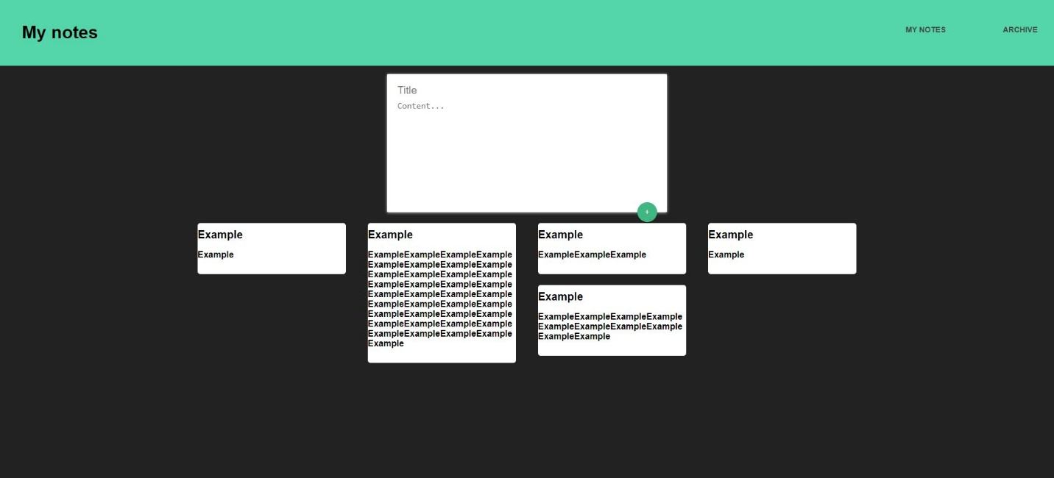

**All the notes**

You can edit the „Title” or the „Content...” by clickingone of the two. You can edit the note while the mouse is hovering over the note.

1. Navigation menu

The navigation menu has two options: „My notes” which sends you to the home page with the input box and all of your notes, and „Archive” which sends you to the archive page where all the archived notes are kept.



1. Input box

In order to create a note, you have to add the title ofthe note and some content to it. If you don’t fill one of the the two, an alert message pops out.

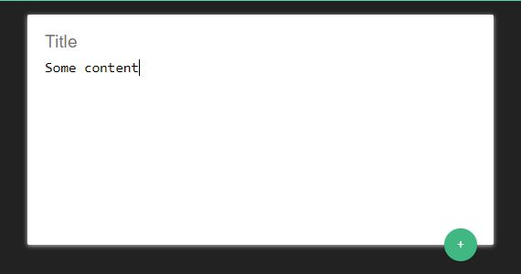

**Click!**

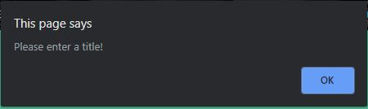

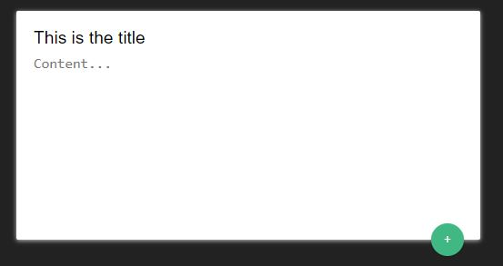

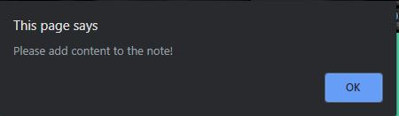

1. Context menu

The context menu is the menu that appears whenever you right click on something. On this website, a custom context menu appears when you right click on a note. The context menu on „My notes” page is different from the context menu on „Archive” page.

This is the context menu on „My notes” page:

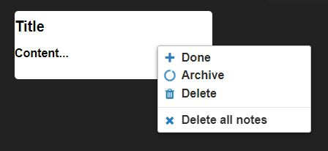

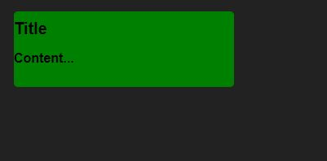

You have the option to change the color of the note, archive it, delete it or to delete all of the notes.

This is the context menu on „Archive” page: